V30 gaming mouse manual
System requirements
• Windows XP/Windows Vista/Windows 7 operating system
• Free USB (1.1/2.0) port
• 30 MB available hard drive space

- Software installation
1. Put the gaming mouse connected to your computer , download the compressed package driver into the computer . Then follow the steps to install the game driver as below.
Open the driver installation files, double-click the “MotoSpeed Gaming MouseV30” icon , installation.
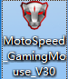
2.Select the installation language and click "OK " and then click "Next。
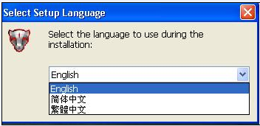
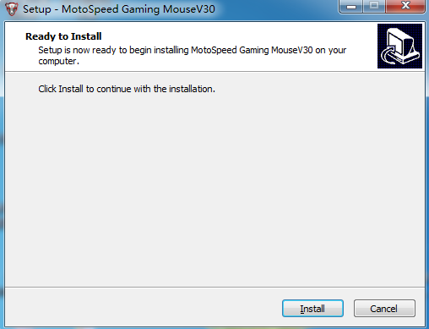
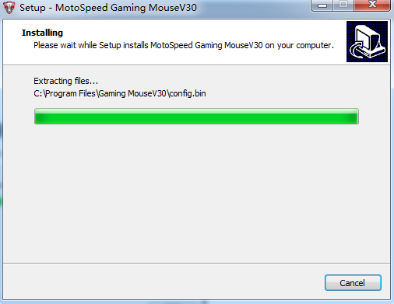
3.Select "Run gm.exe", start the program after installation finished , click "Finish" to complete the installation。
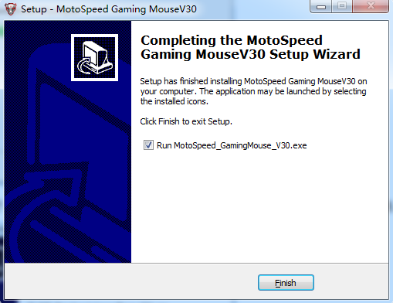

3. After the installation is complete, you will see the program icon ( see Figure red circle part ) in the system taskbar. Double-click the icon to bring up the settings interface
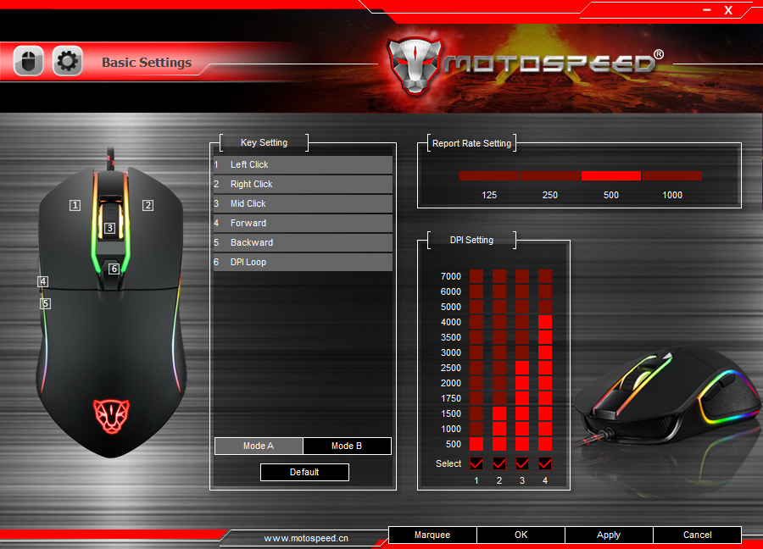

Common function set
1. For example, to make a "mid-click" Setting for et“2” button, need to click the “2” button on theoperation page first, and then double-click on the "mid-key" in the drop-down list box
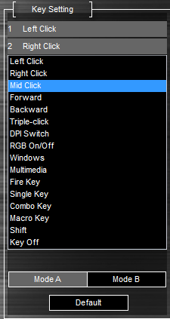
- At this point the configuration of button 3 as below
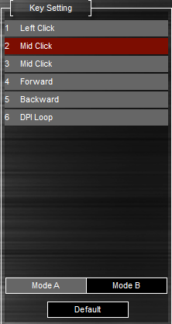

- Click "apply" to save Settings

One-button function set
1. For example, to make a "one-button" setting for“5” button, need to click “5” button on the operationpage first, and then double-click “one-button” in the drop-down list box. 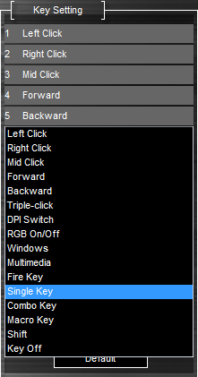
2. Pop-up window, as shown in the figure below,input arbitrary buttons of the keyboard such as "Alt"key.
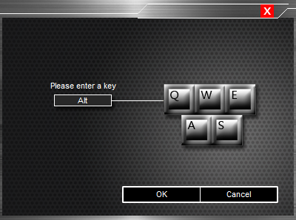
3. At this point the configuration of button 5 as below
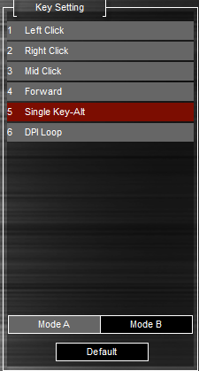
- The click "ok" to close the dialog & save Settings.

Fire key function set
1. For example, to make a "fire key" Settings for “6” button, need to click “6” button on the operation pagefirst, and then double-click“fire key”in the drop-down list box. 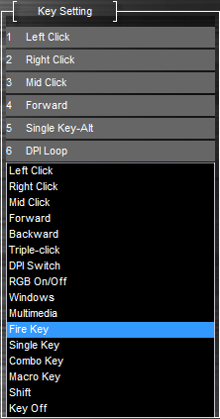
2. Popup window, as shown in the following diagram, select the keyboard keys or mouse buttons from the drop-down list box, input speed and times, for details, please refer to the following figure captions and then click"ok" to close the dialog & save Settings. 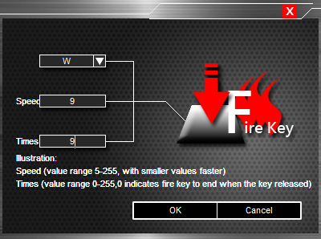
3．At this point the configuration of button 6 as below
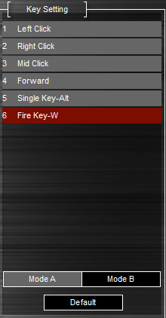
4. The click "ok" to close the dialog & save Settings.

Combo Key function set
1. For example, to make a " combo key " setting for “5” button, need to click “5” button on the operation page first, and then double-click on the " combo key " in the drop-down list box。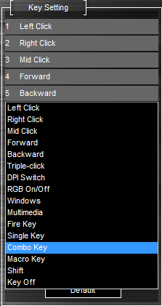
2. Popup window, as shown in the figure below, choose the“Modify”button from the drop-down list box, and input any keys in the edit box, as the chart "Ctrl +A + Alt", then click "ok" to close the dialog & save the Settings。
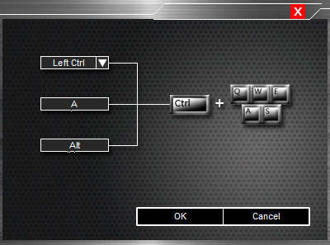

3. At this point the configuration of button 5 as below
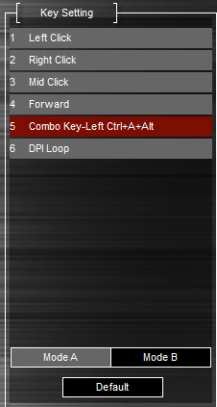
- The click "ok" to close the dialog & save Settings.

Macro Settings
For example, to make a macro definition Settings for “6” button, click the "advanced ettings" TAB first, to do macro Settings, input macro name in "macro name" edit box, such as below image "1", click "new" button, and then click the " start recording" button, input a set of keys in the keyboard, such as "shift + A + B" in the chart, click the "stop recording " button to complete the recording, input digit in the "cycles times" edit box, execute the macro instruction in circulation the number, and click on the "confirm" button to save the Settings finally.
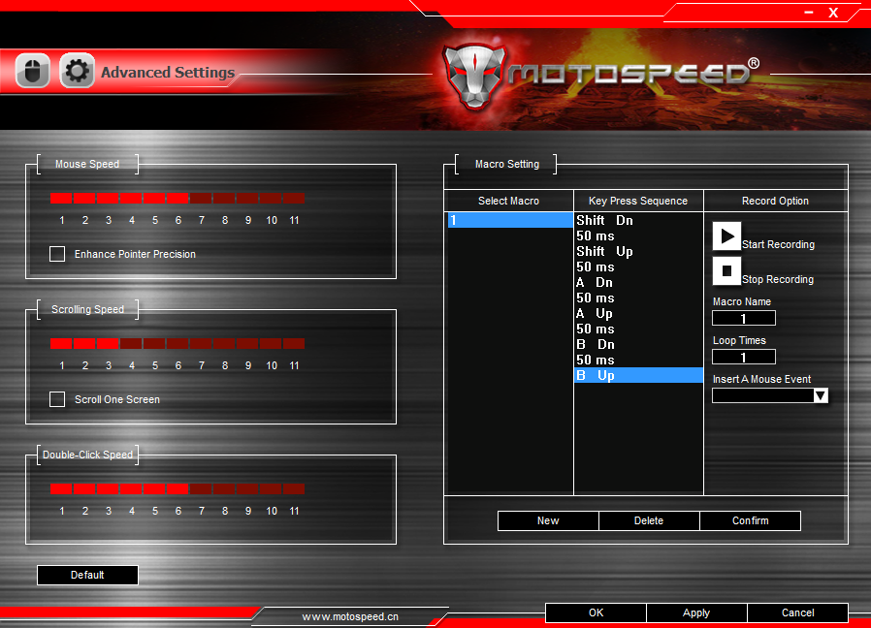
1. Click on the "basic Settings" TAB, click “6”button on the operation page, and then double-click the "macro" in drop-down list box。
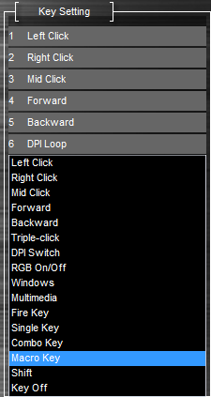
2. Popup window, as shown in figure 12 below, choose macros "1" from the before recording list boxes, Select an option from the three groups on the right to set, then click "ok" to close the dialog & save Settings
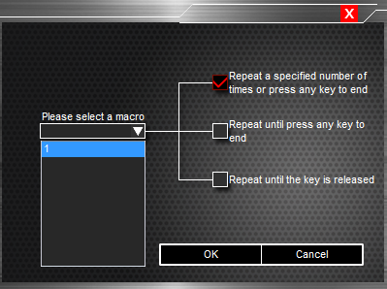
3．At this point the configuration of button 6 as below
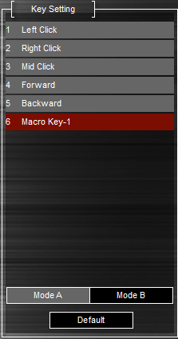
4. The click "ok" to close the dialog & save Settings.

The report rates set
1. Click the "basic Settings" TAB and then through the right photo setting, choose a different rate of report。
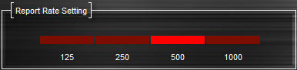
2. Click "apply" to save Settings.

DPI Setting
1. Click“Basic Setup” follow below picture to start related settings of DPI, for example below picture show support 4 DPI switching.
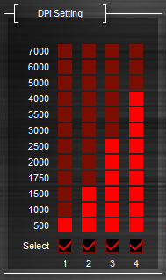
2. Keys can be set to DPI switching function, as show key 4 from below picture 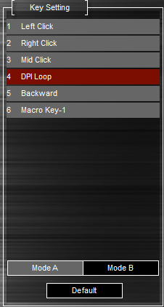
3. Click "apply" to save Settings..
4. Press the “6/7”button, it will popup bubble prompt window in the program tray icon of the system taskbar, it will prompt currently used DPI
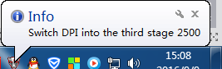

The mouse attribute set
Can proceed the mouse movement speed, wheel speed, and then double-click speed regulation.
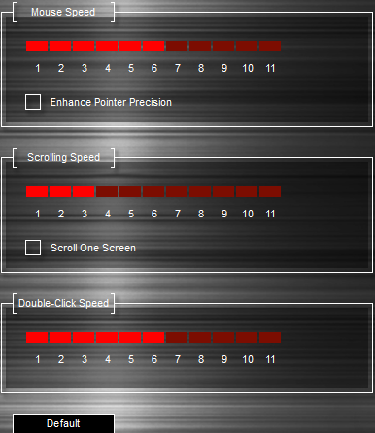

Keyboard & mouse One-button portfolio macro Settings：
1. For example to make a “keyboard & mouse One-button portfolio macro Settings “ for
“2” button, click the "advanced Settings" TAB, carries on the macro Settings, input macro name in the "macro name" edit box, such as the picture "2" below, click on the "new" button, and then click the button "start recording"; Input one button in the keyboard, such as"Q", to insert a mouse events – “R-ButtonClick”, click "stop" button to complete the recording, input digit in the "cycles" edit box, execute the macro instruction in circulation the number, then click"confirmation" to save Settings.
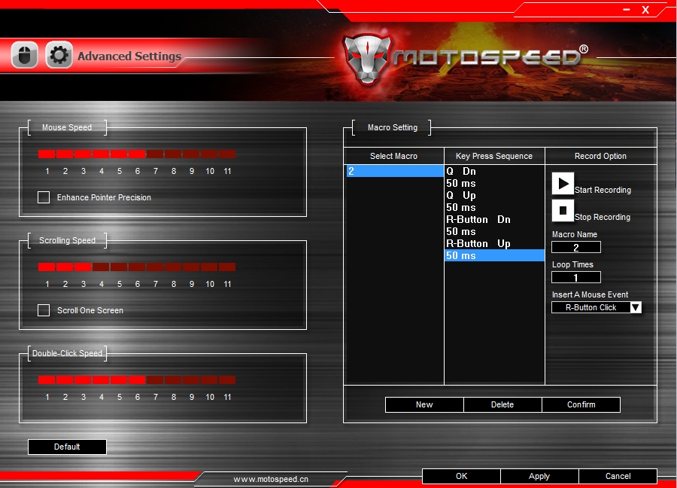
2. Click the "basic Settings" TAB, click on the “2”button on the operation page, and then double-click the "macro" drop-down list box。
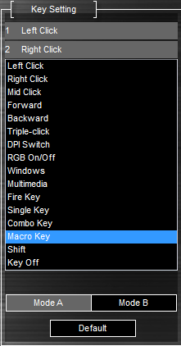
3. Popup window, as shown in the following diagram , choose the set "2" of “keyboard & mouse One-button portfolio macro Settings “which was recorded before from the list boxes, Select an option from the three groups on the right to set, click"ok" to close the dialog & save Settings.
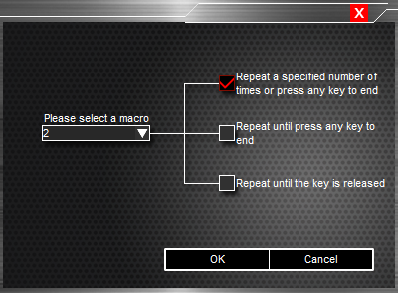
4. At this point the configuration of button 2 as below
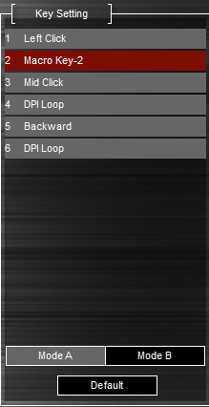
5.Click "apply" to save Settings.

Macro delay setting：
1. For example to make a delay time setting for key, double-click the left key of the mouse, like the picture on the right position
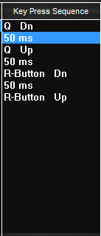
2. Pop up a screen, set a time and then click the "ok"
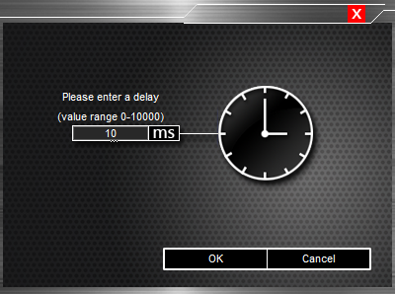
3. Click "OK" to save the settings , the configuration as shown :
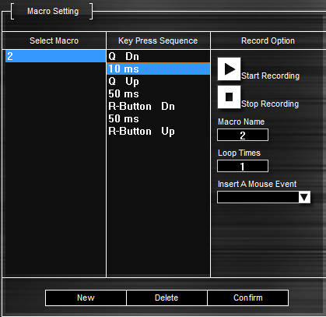

Draw Marquee-LED Banner setting
1. click position 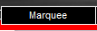，a small pop-up screen, you can set the "Mode", "Brightness", "Speed", "direction" in the following figure:
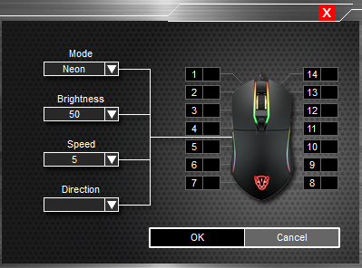
2. First Click OK, then click Apply to save your settings
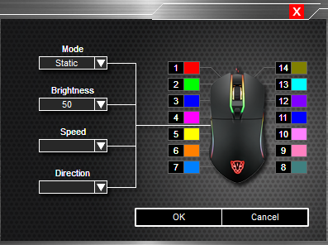

3. In the Static and breathing pattern mode, the 14 RGB lights can be adjusted to 16.8 million colors
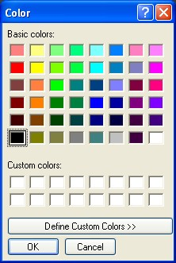

Note: In the static, breathing, neon mode, does not support the "speed and direction function"

Uninstall
Open the Control Panel, open "Add or Remove Programs" window, find click on the "Uninstall" to complete the uninstall process.

